OS Simulator
Operating Systems project


Prince Mohammad Bin Fahd University – Al Khobar
Group Members:
Majid Almislim 202100688
Samer Alnaji 202003052
Aban Alfaify 202200484
Supervisor: Dr. Jawad Alkhateeb

Table of Contents
Introduction 1
CPU Scheduling 1
Explanation 1
Universal Functions 2
FCFS Implementation 2
preemptive SJF Implementation 2
non preemptive SJF Implementation 3
RR Implementation 3
Banker’s Algorithm 4
Explanation 4
Implementation 5
Page Fault Algorithm 6
Explanation 6
FIFO Implementation 7
LRU Implementation 7
Optimal Implementation 8
Performance Metrics 8
Results and Screenshots 9
Conclusion 12
README 12
Code 14
Main_Menu.py 14
CPU_Scheduling.py 15
Bankers.py 20
Pagefault.py 24

Introduction
A major component that impacts the efficacy of an operating system is how efficient it is. Due to the importance of efficiency, it is pertinent that various algorithms and methods be implemented within an operating system to ensure it is running as efficiently as possible. Throughout our time in the Operating Systems Course, we have studied many different algorithms that enable an operating system to run smoothly. Our project aims to simulate the algorithms used within operating systems for various tasks such as scheduling processes, avoiding deadlocks and page faults.

CPU Scheduling

Explanation
CPU scheduling is the organizational process the CPU goes through to order the set of processes it needs to compute. There are several different methods used to schedule CPU processes. In our code we have simulated 4 distinct CPU scheduling Algorithms. The first is First Come First Serve(FCFS) which organizes the processes based on arrival. The two algorithms after that are the same algorithm with slight variation. Shortest Job First (SJF) will prioritize the process with the shortest completion time. This algorithm has two variants, the first is preemptive. Preemptive means that it will interrupt a process if a newer shorter job has been found. Non preemptive will not interrupt any process until completion. The final algorithm is Round Robin (RR). Round Robin will designate a specific time frame called the Quantum Time, this timeframe will be how long it spends on each process. It will iterate through each process until all processes are complete. There are several key factors in determining the efficacy of each algorithm. Here are all the factors and their definitions:
- Arrival Time: The time at which the process arrived into the ready state.
- Burst Time: The duration the process requires to complete.
- Waiting Time: The time the process spent waiting in the ready queue before reaching the CPU
- Turnaround Time: The total time from arrival that the process spent in order to complete.
- Gantt Chart: A graphic that helps visualize the duration each process spends in the CPU.

Universal Functions
While implementing the algorithms in python, we came across a few functions that we could reuse for the implementation of all the algorithms. The following is a brief explanation of said functions:
- calc_times Function: a function used to calculate the waiting time and turn around time of each process.
- show_table Function: a function used to create a table that shows all processes along with their waiting times and turnaround times. This function also calculates the averages of these times.
- show_gantt Function: a function used to create a gantt chart of the scheduled processes.

FCFS Implementation
First Come First Serve’s implementation was fairly simple. We first sort the list of processes by arrival time. In addition, we initialize a variable called “time” to keep track of the current time and a list called “chart” to keep track of information later used in the gantt chart. Then we create a for loop that iterates through the list of processes and checks if the time is less than the current process’ arrival time. If that is the case, then we will advance to the arrival time. Otherwise, we will set the process’ start time to the current time and set its completion time to the current time plus the burst time. Afterward we will add the process to the chart and set the current time to equal the completion time. Afterward we call on the 3 universal functions previously mentioned.

preemptive SJF Implementation
Preemptive Shortest Job First starts very similarly with the initialization of a variable to track the current time and a list to keep track of the chart. We use a while statement to ensure the algorithm remains active while any process still has time remaining to reach completion. we then use the “ready” list to filter out any processes that have yet to arrive as well as any processes that have completed. we then have an if statement that checks if the list contains any values. If it does then it will pick the smallest value from the ready list.. after it will run a nested if statement that will check if it is the first time the process runs. It will then record the start time. If it is the same process running it will extend the chart bar. If it picks a new process then it will start a new bar in the gantt chart. Finally, it will record the completion time if the process has 0 remaining. It will repeat the entire algorithm until there are no longer any processes that require computation.

non preemptive SJF Implementation
Non Preemptive SJF follows a similar line of logic. We have the same variables in addition to a different list called “done”. This list will keep track of all completed processes. We have a while loop that remains active as long as the length of the done list is smaller than the length of the list of processes. We then create a ready list that filters out any processes that have yet to arrive and any processes that have already completed. After that, we have an if statement that checks if there are any values in the ready list. if there are then it will pick the smallest value from the ready list. After that we will set the start time to the current time and the completion time to the current time plus the burst time. we then add the information to the chart and set the current time to the completion time. Finally we add the process to the done list. if there are no processes ready then we will increment the time until they are ready. This will repeat until there are no processes that need to be completed.

RR Implementation
Round Robin implementation also starts by initializing a variable to monitor the current time and a list to construct the gantt chart. Additionally, a list named "remaining" is utilized to monitor how much burst time remains for each process, and a "visited" list to avoid adding the same process to the queue more than once upon arrival. We utilize a queue to handle the order of execution. Most of the logic is a while loop which runs until all processes are finished. Within the loop, we first see whether there are any newly arrived processes that have not been visited and insert them into the queue. If the queue is empty, we just increment the time. Otherwise, we dequeue the first process and execute it for the length of the quantum or the remainder of its time, whichever is less. If it's the first run of the process, we set its start time. We update the gantt chart, remove the runtime from the process' remaining time, and increment current time. If the process has time remaining after the quantum, we search for newly arrived processes and add the current one to the rear of the queue. If the process completes, we note its completion time. The loop continues until all processes have no remaining time. At last, we utilize the universal functions to compute waiting and turnaround times and print the output in a table and a gantt chart.

Banker’s Algorithm

Explanation
The Banker's Algorithm is a simple deadlock avoidance and resource allocation algorithm used in operating systems. It assists the system in allocating only those requests for resources that will leave the system in the safe state where all the processes can complete without resulting in deadlocks.
The algorithm operates on the optimistic allocation principle: it simulates the allocation of requested resources and verifies whether the system will still be in a safe state prior to finalizing the allocation. If the system will be unsafe, then the allocation is aborted.
Key concepts involved in the Banker's Algorithm include:
- Available Vector: Represents the number of available instances for each resource type.
- Maximum Matrix (Max): Indicates the maximum demand of each process for each resource.
- Allocated Matrix: Represents how many resources of each type are currently allocated to each process.
- Need Matrix: Derived from Max - Allocated, this shows the remaining resources each process will need to complete.
A safe state is a state in which the system can find a sequence of executions in which every process can get the resources it requires, finish, and release the resources for use by other processes. The safety algorithm checks if the system is in such a state.
This implementation also includes a request algorithm where a process requests additional resources. The request is granted only if it:
- Does not exceed the process’s remaining need.
- Does not exceed the currently available resources.
- Leaves the system in a safe state after hypothetical allocation.

Implementation
1. Input Handling and Data Structures:
- The function readingvector(prompt, m) reads a vector of integers from the user and is responsible for getting the right number of inputs.
- The readmatrix(name, processes, resources) function reads in a matrix (list of lists) for either the Max or Allocated matrices for all processes.
- These inputs constitute the foundation of the initial state of the system.
2. Need Matrix Calculation:
- Used in calculate_need(Max, allocated), this operation does the subtraction of the allocated values from the maximum needs of each process.
- The resulting matrix depicts the number of additional resources each process can further request to complete execution.
3. Safety Algorithm (Deadlock Avoidance):
- Used in safetycheck(available, allocated, need), the procedure checks if the current state of the system is safe.
- It simulates the execution of processes by:
  - Checking if the requirements of a process can be fulfilled with currently available resources.
  - If so, the process is assumed to terminate, and its allocated resources are released back to the system.
  - This goes on until all processes stop (safe state) or no further progress is possible (unsafe state).
- If a safe sequence is found, it is returned; otherwise, the system is considered to be unsafe.
4. Managing Resource Request
- Implemented in request(available, allocated, need), this function allows a process to request additional resources while it is running.
- The application is approved only if:
  - It is not greater than the process's declared maximum need.
  - It never goes beyond what is available.
  - The state is still secure following the interim allocation.
- If they are satisfied, the system confirms the assignment and modifies its state.
- If not, all changes are rolled back to preserve stability.
5. Main Execution Flow:
- The program takes inputs and calculates the Need matrix.
- It displays the current state, the Available, Max, Allocated, and Need matrices.
- It performs a safety test and, optionally for the user, allows testing of a resource request.

Page Fault Algorithm

Explanation
Page replacement is an important memory management operation in operating systems. If a process accesses a page that is not in main memory (a page fault), the operating system needs to bring the page from secondary storage into memory. If all the frames in memory are full, however, the system needs to determine which page to replace to accommodate the new one. The page replacement algorithms control the decision-making process, and their main goal is to minimize the page fault rate and enhance performance.
In the simulation, a reference string is the list of pages requested by a process. Memory contains a fixed amount of frames (frame size), and the program computes the page faults and hits for both algorithms. A page hit is when the requested page is in memory. Both of these are tracked by the system to calculate the hit rate and miss rate as performance measures.

FIFO Implementation
The First-In First-Out (FIFO) page replacement algorithm is the simplest and earliest page replacement algorithm. It maintains the pages in the same sequence as they are brought into memory. When a page fault occurs and memory is full, the algorithm replaces the page that has been in memory the longest—regardless of how frequently or recently it has been used.
How it works:
- A list is used to represent the memory frames.
- For each page in the reference string:
  - If the page is not in memory, a page fault occurs.
  - If memory has available space, the page is appended.
  - If memory is full, the first page (oldest) is removed and replaced with the new page.
- The total number of page faults and hits are tracked.

LRU Implementation
The LRU algorithm replaces the page that has been unused the longest. It is less likely that the most recently used pages will not be used and the pages that are unused for a longer period of time are less likely to be used in the immediate future.
How it works:
- Two lists are used:
  - One to hold the current pages in memory.
  - Another to track the usage history (most recently used at the end).
- For each page in the reference string:
  - If the page is already in memory (a hit), it is moved to the end of the usage list.
  - If the page is not in memory (a fault):
    - If memory has space, the page is added.
    - If memory is full, the least recently used page (the first in the usage list) is replaced.
- The list is updated on every page access to maintain the usage order.

Optimal Implementation
The Optimal Page Replacement or MIN or OPT algorithm is an ideal one that always makes the optimum choice. It replaces the page that will not be accessed for the longest time in the future. It is an idealistic approach in real-time systems since it needs information about future page references in advance but serves as a good standard to compare how well other algorithms perform.
How it works:
- For each page in the reference string:
  - If the page is already in memory, it’s a hit.
  - If the page is not in memory, it’s a fault.
    - If there is space, the page is added to memory.
    - If memory is full:
      - The algorithm looks ahead in the reference string.
      - For each page currently in memory, it checks when it will next be used.
      - The page with the farthest next use (or not used again at all) is replaced.
- This logic minimizes the chance of needing to reload a recently evicted page.

Performance Metrics
The program calculates the following metrics for each algorithm:
- Page Faults: Number of times a requested page was not in memory.
- Hits: Number of times a requested page was already in memory.
- Miss Rate: Ratio of faults to total page requests.
- Hit Rate: Ratio of hits to total page requests.
These metrics are organized into a table using the tabulate module for easy comparison.

Results and Screenshots
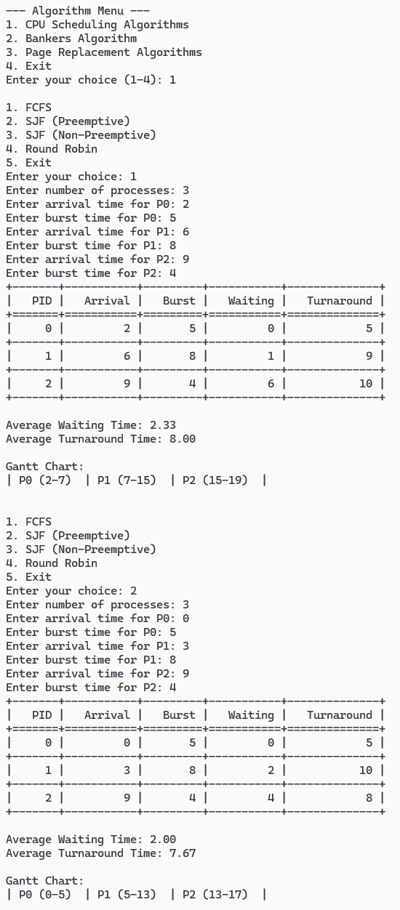
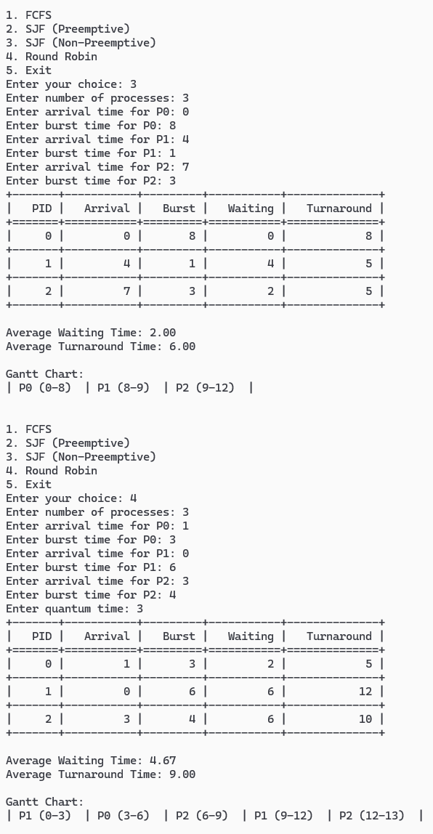
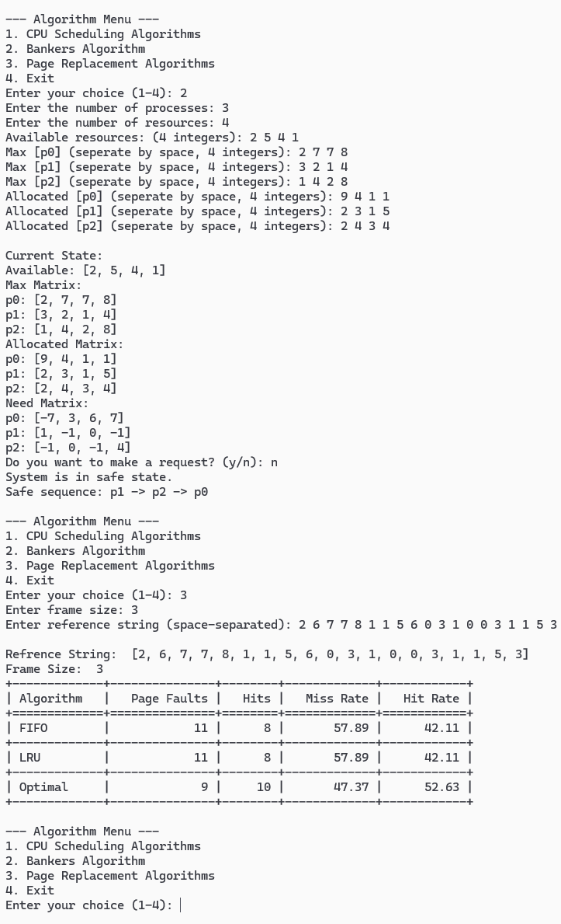

Conclusion
Our simulation of the various algorithms we studied allowed us to better understand the concepts that we were taught. Recreating the algorithms forced us to take a deeper look at the intricacies. Under this lens of scrutiny, we were able to see the faults within some of the algorithms. The flaws in each design became clearer as we were developing the simulation. In conclusion, our simulation of the operating system algorithms allowed us to create a better understanding of how these algorithms work and what makes an algorithm more or less efficient.

README
# Operating Systems Algorithms Simulator
This project simulates key Operating System algorithms:
- **CPU Scheduling Algorithms** (FCFS, SJF, Round Robin)
- **Banker's Algorithm** (Deadlock Avoidance)
- **Page Replacement Algorithms** (FIFO, LRU, Optimal)
All algorithms are accessible from a **central menu** that allows users to select and run simulations easily.
---
## 📁 File Structure
```
OS Project/
│
├── main_menu.py # Launch this file to start the menu
├── CPU_Scheduling.py # CPU scheduling simulation
├── Bankers.py # Banker's algorithm simulation
├── Pagefault.py # Page replacement simulation
└── README.md # You're reading this!
```
---
## ✅ Requirements
- Python 3.x
- `tabulate` library (used to display tables for some algorithms)
### 🔧 Install `tabulate`
Open Command Prompt or Terminal and run:
pip install tabulate
---
## 🚀 How to Run
> 🔹 **Recommended:** Run from the Command Prompt / Terminal
1. Launch the main menu:
click on "main_menu.py"
2. You'll see this menu:
```
--- Algorithm Menu ---
1. CPU Scheduling Algorithms
2. Bankers Algorithm
3. Page Replacement Algorithms
4. Exit
```
3. Enter your choice (1–4) to run the corresponding algorithm.
---
## 🧠 How Each Algorithm Works
### 1. CPU Scheduling Algorithms
When selected, the program asks:
- Number of processes
- Arrival time (0 if not provided)
- Burst time
- Quantum (for Round Robin)
Available Algorithms:
- FCFS (First Come First Serve)
- SJF Non-Preemptive
- SJF Preemptive
- Round Robin
**Outputs:**
- Gantt Chart
- Table of Process details
- Average Waiting Time
- Average Turnaround Time
---
### 2. Banker's Algorithm
Used for **Deadlock Avoidance**.
Prompts for:
- Number of processes
- Number of resource types
- Allocation, Maximum, and Available resources
**Outputs:**
- Whether the system is in a **safe state**
- Safe sequence (if any)
---
### 3. Page Replacement Algorithms
Prompts for:
- Frame size
- Reference string (space-separated)
Algorithms simulated:
- FIFO (First In First Out)
- LRU (Least Recently Used)
- Optimal
**Outputs:**
- Page fault count
- Hit & Miss ratios
- Frame-by-frame table (via `tabulate`)
---
## 📝 Notes
- Scripts use `subprocess` to run individual algorithms in separate processes.
- Works best in a **terminal environment**.
- Ensure Python and `tabulate` are installed before starting.
---
- Developed for academic purposes as part of the Operating Systems project.

Code

Main_Menu.py
import subprocess
import sys

def main():
while True:
print("\n--- Algorithm Menu ---")
print("1. CPU Scheduling Algorithms")
print("2. Bankers Algorithm")
print("3. Page Replacement Algorithms")
print("4. Exit")

choice = input("Enter your choice (1-4): ")

if choice == '1':
subprocess.run([sys.executable, "CPU_Scheduling.py"])
elif choice == '2':
subprocess.run([sys.executable, "Bankers.py"])
elif choice == '3':
subprocess.run([sys.executable, "Pagefault.py"])
elif choice == '4':
print("Exiting...")
break
else:
print("Invalid choice. Please enter a number from 1 to 4.")

if __name__ == "__main__":
main()

CPU_Scheduling.py
from tabulate import tabulate

class Process:
def __init__(self, pid, arrival, burst):
self.pid = pid
self.arrival = arrival
self.burst = burst
self.remaining = burst
self.waiting = 0
self.turnaround = 0
self.start = -1
self.completion = 0

def calc_times(processes):
for p in processes:
p.turnaround = p.completion - p.arrival
p.waiting = p.turnaround - p.burst

def show_table(processes):
table = [[p.pid, p.arrival, p.burst, p.waiting, p.turnaround] for p in processes]
avg_wt = sum(p.waiting for p in processes) / len(processes)
avg_tat = sum(p.turnaround for p in processes) / len(processes)
print(tabulate(table, headers=["PID", "Arrival", "Burst", "Waiting", "Turnaround"], tablefmt="grid"))
print(f"\nAverage Waiting Time: {avg_wt:.2f}")
print(f"Average Turnaround Time: {avg_tat:.2f}")

def show_gantt(chart):
print("\nGantt Chart:")
for start, end, pid in chart:
print(f"| P{pid} ({start}-{end}) ", end=" ")
print("|\n")

def fcfs(processes):
processes.sort(key=lambda p: p.arrival)
time = 0
chart = []
for p in processes:
if time < p.arrival:
time = p.arrival
p.start = time
p.completion = time + p.burst
chart.append((p.start, p.completion, p.pid))
time = p.completion
calc_times(processes)
show_table(processes)
show_gantt(chart)

def sjfP(processes):
time = 0
chart = []
last_pid = -1
while any(p.remaining > 0 for p in processes):
ready = [p for p in processes if p.arrival <= time and p.remaining > 0]
if ready:
p = min(ready, key=lambda x: x.remaining)
if p.start == -1:
p.start = time
p.remaining -= 1
if last_pid != p.pid:
chart.append((time, time + 1, p.pid))
else:
chart[-1] = (chart[-1][0], time + 1, p.pid)
last_pid = p.pid
time += 1
if p.remaining == 0:
p.completion = time
else:
time += 1
last_pid = -1
calc_times(processes)
show_table(processes)
show_gantt(chart)

def sjfNP(processes):
time = 0
chart = []
done = []
while len(done) < len(processes):
ready = [p for p in processes if p.arrival <= time and p not in done]
if ready:
p = min(ready, key=lambda x: x.burst)
p.start = time
p.completion = time + p.burst
chart.append((p.start, p.completion, p.pid))
time = p.completion
done.append(p)
else:
time += 1
calc_times(processes)
show_table(processes)
show_gantt(chart)

def rr(processes, quantum):
time = 0
chart = []
remaining = [p.burst for p in processes]
n = len(processes)
last_pid = -1
queue = []
visited = [False] * n

while True:
for i in range(n):
if processes[i].arrival <= time and not visited[i]:
queue.append(i)
visited[i] = True

if not queue:
time += 1
continue

i = queue.pop(0)
p = processes[i]

if p.start == -1:
p.start = time

curr_quantum = min(quantum, remaining[i])
remaining[i] -= curr_quantum

if last_pid != p.pid:
chart.append((time, time + curr_quantum, p.pid))
else:
chart[-1] = (chart[-1][0], time + curr_quantum, p.pid)

last_pid = p.pid
time += curr_quantum

if remaining[i] == 0:
p.completion = time
else:
for j in range(n):
if processes[j].arrival <= time and not visited[j]:
queue.append(j)
visited[j] = True
queue.append(i)

if all(r == 0 for r in remaining):
break

calc_times(processes)
show_table(processes)
show_gantt(chart)

def get_processes():
n = int(input("Enter number of processes: "))
plist = []
for i in range(n):
a = int(input(f"Enter arrival time for P{i}: "))
b = int(input(f"Enter burst time for P{i}: "))
plist.append(Process(i, a, b))
return plist

def main():
while(True):
print("\n1. FCFS\n2. SJF (Preemptive)\n3. SJF (Non-Preemptive)\n4. Round Robin\n5. Exit")
choice = int(input("Enter your choice: "))
if choice == 5:
break
plist = get_processes()
if choice == 1:
fcfs(plist)
elif choice == 2:
sjfP(plist)
elif choice == 3:
sjfNP(plist)
elif choice == 4:
quantum = int(input("Enter quantum time: "))
rr(plist, quantum)
else:
print("Invalid choice. Please try again.")

if __name__ == "__main__":
main()

Bankers.py
def readingvector(prompt, m):
while True:
parts = input(prompt).split()
if len(parts) == m:
return list(map(int, parts))
print(f"Please enter exactly {m} integers.")

def readingmatrix(name, processes, resources):
matrix = []
for p in range(processes):
while True:
row = readingvector(f"{name} [p{p}] (seperate by space, {resources} integers): ", resources)
matrix.append(row)
break
return matrix

def calculate_need(Max, allocated):
need = []
for i in range(len(Max)):
row = []
width = len(Max[0])
for j in range(width):
row.append(Max[i][j] - allocated[i][j])
need.append(row)
return need

def safetycheck(available, allocated, need):
process = len(allocated)
resources = len(available)

work = available.copy()
finish = [False] * process
safe_sequence = []

while len(safe_sequence) < process:
found = False
for p in range(process):
if not finish[p] and all(need[p][r] <= work[r] for r in range(resources)):
for r in range(resources):
work[r] += allocated[p][r]
finish[p] = True
safe_sequence.append(p)
found = True
break
if not found:
return False, []
return True, safe_sequence

def request(available, allocated, need):
process = len(allocated)
resources = len(available)

p= int(input(f"Enter the process number: (0 to {process-1}) p"))

request = readingvector(f"Request for process p{p}: ({resources} integers)", resources)

for r in range(resources):
if request[r] > need[p][r]:
print("Request is higher than need. request denied.")
return
for r in range(resources):
if request[r] > available[r]:
print("Not enough resources available.")
return

old_available = available.copy()
old_allocated = [row.copy() for row in allocated]
old_need = [row.copy() for row in need]

for r in range(resources):
available[r] -= request[r]
allocated[p][r] += request[r]
need[p][r] -= request[r]

safe, sequence = safetycheck(available, allocated, need)
if safe:
print("Request granted. system remains in a safe state.")
print("New safe sequence:", " -> ".join(f"p{i}" for i in sequence))
else:
print("Request cannot be granted. Reverting changes.")
available[:] = old_available
for i in range(process):
allocated[i] = old_allocated[i]
need[i] = old_need[i]

print("\n After request, state is:")
print("Available:", available)
print("Allocation")
for i in range(process):
print(f"p{i}: {allocated[i]}")
print("Need")
for i in range(process):
print(f"p{i}: {need[i]}")

if __name__ == "__main__":
process = int(input("Enter the number of processes: "))
resources = int(input("Enter the number of resources: "))
available = readingvector(f"Available resources: ({resources} integers): ", resources)
Max = readingmatrix("Max", process, resources)
allocated = readingmatrix("Allocated", process, resources)

print("\nCurrent State:")
print(f"Available:", available)
print("Max Matrix:")
for i in range(process):
print(f"p{i}: {Max[i]}")
print("Allocated Matrix:")
for i in range(process):
print(f"p{i}: {allocated[i]}")

need = calculate_need(Max, allocated)
print("Need Matrix:")
for i in range(process): print(f"p{i}: {need[i]}")

safe, sequence = safetycheck(available, allocated, need)

answer = input("Do you want to make a request? (y/n): ")
if answer.lower() == 'y':
request(available, allocated, need)
elif answer.lower() == 'n':
if safe:
print("System is in safe state.")
print("Safe sequence:", " -> ".join(f"p{i}" for i in sequence))
else:
print("System is not in safe state.")

Pagefault.py
from tabulate import tabulate

def FIFO(ref, f_size):
memory = []
p_faults = 0
for page in ref:
if page not in memory:
p_faults += 1
if len(memory) < f_size:
memory.append(page)
else:
memory.pop(0)
memory.append(page)
hits = len(ref) - p_faults
return p_faults, hits, p_faults / len(ref), hits / len(ref)
def LRU(ref, f_size):
memory = []
recent = []
p_faults = 0
for page in ref:
if page in memory:
recent.remove(page)
recent.append(page)
else:
p_faults += 1
if len(memory) < f_size:
memory.append(page)
recent.append(page)
else:
lru = recent.pop(0)
i = memory.index(lru)
memory[i] = page
recent.append(page)
hits = len(ref) - p_faults
return p_faults, hits, p_faults / len(ref), hits / len(ref)

def optimal(ref, f_size):
memory = []
p_faults = 0
for i in range(len(ref)):
page = ref[i]
if page not in memory:
p_faults += 1
if len(memory) < f_size:
memory.append(page)
else:
future = ref[i+1:]
i = []
for m_page in memory:
if m_page in future:
i.append(future.index(m_page))
else:
i.append(float('inf'))
repl = i.index(max(i))
memory[repl] = page
hits = len(ref) - p_faults
return p_faults, hits, p_faults / len(ref), hits / len(ref)

def show_Ptable(ref, f_size):
print("\nRefrence String: ", ref)
print("Frame Size: ", f_size)

table = []
headers = ["Algorithm", "Page Faults", "Hits", "Miss Rate", "Hit Rate"]
for s, func in [("FIFO", FIFO), ("LRU", LRU), ("Optimal", optimal)]:
faults, hits, miss_rate, hit_rate = func(ref, f_size)
table.append([s, faults, hits, f"{miss_rate*100:.2f}", f"{hit_rate*100:.2f}"])

print(tabulate(table, headers=headers, tablefmt="grid"))

if __name__ == "__main__":
f_size = int(input("Enter frame size: "))
ref_input = input("Enter reference string (space-separated): ")
ref = list(map(int, ref_input.split()))
show_Ptable(ref, f_size)

